URBACT Proposal on

design in the elaboration of public services

strategic goal and vision

We aim at making public administration better able answer citizens’ need through the use of users- centred design methods.
This URBACT Action Planning Network would enable participatory cities to exchange knowledge, know-how, and best practices regarding the uses of design methods in the process of policy making from elaboration to implementation. Each partner will have to implement learning outcomes and test the transformation of their administration on a chosen policy field at their local level.
Design is particularly valuable since it can, and must, be applied to a broad spectrum of public policies and services. We ambition to create a partnership where each partner could bring its own experience in the policy field they believe design methods are the most needed for their local context.

The project rationalE

Policy Challenge
Aligning services and needs: Most local governments in Europe acknowledge their need to turn from a purely administrative body to a lever of innovation for their territory. They have to face transformations which demand strong innovative, creative, disruptive capacity of public administration. However, pushing for innovativeness in public local administration requires skills and methods since innovative actions may not be aligned with real user needs. Innovation actions which have not went through a specific process may lead into pitfall like non-use of public services, non-use of the allocated budget, low participation, mismatch between services and real needs, targeting wrong user groups etc. For instances, financial supports helping retrofit private housing for energy saving purposes exist in many regions but are almost always under-used, just alike public libraries which are under-used due to their irrelevant opening times etc. Disregarding participatory methodologies, cities are only rarely able to make real changes requested by users.
These issues are due to the lack of user-centred approach/mind-set within public administration. The notion of user-centred approach answers the challenges faced by public sector to spot the difficulties of public sector to address the issue of commons, to better synergize with social innovation, etc. User-centred approach are tools to involve stakeholders and to stress key issues as the heaviness of public administration slowing territorial development, discouraging innovation in other sector fo the society, etc.).
2) Finding the right method: Many methodologies exist to foster innovation within public administration out of which one is emerging rapidly in Europe and worldwide in the name of design approaches. This trend is mimicking methods used by industrial designers to best fit final users’ needs. Unlike participatory approaches, design methods do not only listen to users but aim at co-creating with users from ideation to implementation. These design methods are the most relevant ones as it is the link, the crossover between closed innovation process and participatory approaches. Both closed, in-house innovation process on the one hand and conventional participatory approaches on the other hand have shown their limits.
3) Mastering design methods: Design methods allow an empowerment of public administration toward user-centric innovations. If, and only if they are handled wisely (well-targeted etc.), design methods give ways to deal with the metropolitan fragmentations, connect local neighbourhood, spatial planning etc. This approach is getting widely used but it requires experience and knowledge to run an administration with design at its core, direct design actions/investments strategically as well as to assess their effectiveness. The project thereof proposes to compare, assess, conflict our different methods to transform local administration and make us use, benefit from the design methods fully while controlling still the transformation. We want to test effectiveness of this promising approach, define in which condition it is more effective, improve it, etc.

- Policy challenge = how to make public services more efficient in matching user expectations through the use of design approaches?

Links to EU strategy and SDGs
The EU 2020 strategy argues that Europe must “develop its own distinctive and “broader” approach to innovation which addresses the major societal challenges and involves all actors and regions in the innovation cycle”. The design approach opens up new opportunities and new integrated ways to tackle challenges for cities. The closeness of city governments to users, local firms, and knowledge producers must be better valued than with classic participatory approaches to create a better “innovation ecosystem” within the public administration.
Design methods uses different tools to include final users in the different stages of the innovation cycle from ideation to full-scale application. Design can ensure that innovation is “smarter” in the sense of matching the real needs and potential of local organisations and inhabitants will save time, resources, and energy in the long run.
Embracing design is a priority of the European Union since 2011 when, to improve the impact of innovation policies and speed up the uptake of design for innovation, the Commission launched 'the European Design Innovation Initiative' which underlined the need to considerate design as a tool for user-centric innovation.
Moreover, many Sustainable Development Goals (SDGs) can be tackled through the inclusion of design in public administration. The report 'Design for Growth and Prosperity' produced by the European Leadership Board Report in 2012 explains how design can participate to social well-being (SDG 3 “Good health and well-being for people”), to innovate educative systems (SDG 4 “Quality Education”); the report also shows that 80% of the impact of a product or service is determined in the design phase therefore action to improve design effectiveness can lead to significant reduction in environmental impact (SDG 12 “Responsible consumption and production”); as initially though for, design methods also help industries to innovate (SDG 9 “Industries and Innovation”).
Finally, the Pact of Amsterdam, signed by EU ministers of urban affairs, also emphasises the need for urban innovative actions involving local stakeholders to solve multi-level and multi-sectors barriers.
The APN (Action Planning Network) will exchange upon the best way to make this innovation real, to strengthen local capacities on integrated and sustainable urban development, to improve the capacity of cities to manage sustainable urban policies and practices in an integrated and sustainable way.
- Links to EU strategy = find ways to make design-based innovation concrete in local governments

Added value compared to past URBACT projects
A previous URBACT Action Planning Network intending to use design methods to innovate public policies just finished in May 2018. This project, titled CHANGE!, was focusing on using design methods in the elaboration and renewal of social services uniquely (http://urbact.eu/change); in this project, we want to build up on CHANGE! findings and outputs to focuses on transversal issues which public administrations are facing when willing to use design methods. We will focus on the public administration modus operandi so that local public agents can use design methods on (almost) any policy issues their local territory is facing.
Three transversal issues will be tackled:
- Targeting design processes to the right policies, the right users at the right time
- Investing, managing a concrete space for design in a multilevel, multisector governance
- Assess the added-value of design and of its impact
Through these questions, we tackle issues raised by design methods in the elaboration of public services throughout the whole process: before using design, while running a design-centred administration, and design methods’ assessments a posteriori. This original focus on the period after using design is only possible due to the participation of highly experienced cities.
The project also follows-up on previous URBACT involving citizens in the co-production of public actions (such as BoostINNO) by adapting the public administrative structure.
- Added-value = focus on how to concretely adapt the public administration to best integrated design skills in their governance.

The project’s targeted audience
Today, cities’ inhabitants are simple, passive users of public services. They act as consumers not involved in the elaboration of the public services they simply consume. Users of public services must be more active. Their participation to the city’s life in co-creating these services will make them citizens strictly speaking. In that sense, users are the final target of the project.
However the APN will produces integrated action plans directed to change public agents’ behaviours toward innovation and public participation. The target audience is therefore the public administration in the first place but also private parties and associations working with public administrations to make them more innovative for a better response to final user’s needs.
As said above, the final beneficiaries of the shift we want to create in our public administration are the users of public services: these users can be within the public administration (e.g. operational department as users of supportive department), users as private workers use public administration as customers (e.g. workers in waste recycling sites), private individuals using a specific public service to work (e.g. start-ups growing up in business incubators) or any citizens using public services (e.g. users of public transportation).

PARTNERS PRESENTATION and fields of implementation
Action Planning Network is composed of two phases. A first 6-month long phase for the definition of the final partnership and the development of a complete project proposal in the form of a phase 2 application. The phase 2 lasts 24 months is dedicated to implementation and is composed to 8 to 12 cities. This section outlines the assets and local challenges of the 6 cities we think the first group should be composed of.

Lead Partner: Lille Metropole and design, the beginning of a success-story
As former industrial city, the metropolitan area of Lille have had to undergo a radical economic shift. In order to rethink the economy of the Metropole, rethink its advantages and its large potential, private companies and industrialists in particular have fully embraced design methodologies to answer the new needs of a fast changing society and Metropole. Examples of design uses since late 20th century are endless. Design methods have enable Lille Metropole to renew its textile activities into high added-value industries (sportswear, tools and DIY etc.). Retail and mass-distributions have also been transformed by Lille entrepreneurs to better fit new needs. Architecture and urban design have brought live to the dynamic Euralille business district as well as the many industrial brownfields. Today design methods are used to create the most appropriate environment for start-ups and entrepreneurs
Beside this economic revival and in order to cope with various major risks and challenges like poverty, long-term unemployment, attractiveness etc., Lille Metropole has been developing for two decades long-term urban regeneration and social inclusion strategies. Ambitions are high and obstacles many to make Lille Metropole urban life as innovative as its economy. To achieve this ambitious transformation, new ways of thinking the future of the city must be facilitated, design uses must be transferred from the economic to the administration world.
Design methods can be a bridge public administration with public services’ final users but also the different levels of governance and the silos of the administration. Among other transformation, Lille Metropole is creating a laboratory for public policies design.
Lille Metropole Word Design Capital will be in 2020 a milestone of this transformation through design.

Other first phase partners
Most of all cities which have expressed their interest in this project (through the questionnaire and preparatory meeting) are indeed highly relevant and can potentially be legitimate partners.
As it is today, below are presented the cities foreseen to compose the first group during the 6-month first phase. They form a coherent group of highly relevant cities able to shape the program for the 24-month implementation phase.
This first group is a suggestion made by the lead partner and does not mean the formal commitment of the suggested cities nor excluded other cities to be part of the first group. Discussions between partners will be led to determine this.

Baia Mare (RO) is the main city of a metropolitan area of 215,932 inhabitants (44.6% of the county population), an area of 1,395.38 km2, and includes the municipality of Baia Mare, five towns and 13 communes. Baia Mare faces difficulties in answering new needs brought by economic development and its location as a regional transit hub. In Baia Mare, citizens were always waiting for actions from the Local Authority but seemed rarely satisfied with the initial proposals. Baia Mare therefore has entered a transformative process strongly supported by the Mayor to incorporate bottom-up approaches in their policy making. An ecosystem of brokers between civil servants and citizens have been created notably through the participation of previous URBACT project, BoostINNO. Entrepreneurs, associations, universities have been empowered as brokers.
Baia Mare’s institutions were therefore restructured as to respond to the demand of the citizens. Assure the creation of “smart neighbourhoods” with active participation and co-creation of the city also by citizens. Identify and develop innovations which will support continuous long- term improvement of quality of life. Starting from the fact that Design methods is a process of problem solving that begins with understanding unmet stakeholder needs, and represents a process for innovation that encompasses concept development, applied creativity, prototyping, and experimentation. Baia Mare succeeded to change the perception among the citizens participating to co-construction meetings. Baia Mara now has good experience in pushing public employees to be more innovative through internationalisation and have already used design for social innovation.
Other challenges are still ahead of Baia Mare such as addressing the absence of proper spaces where new ideas should be generated and tested, strengthening mutual trust between civil servants and final users, using more advanced co-design methods, stimulating input at all levels of participatory development, from challenge identification to proposals and implementation, monitoring. Baia Mare is in a nutshell looking to the European new co-design trends and testing new models to understand how to apply them to local contexts and local realities.

The municipality of Torino (IT), with a population approaching 900.000, was the first World Design Capital in 2008. WDC2008 celebrated Turino’s excellence in industrial design and culture, creative industry. Since then, the seeds of social design and experimental design have grown.
Since then, Torino has shifted and is now using design methods to improve its social policies, to formulate a better response to labour and housing issues of marginalized people, to elaborate methods to test social innovation… Torino also works closely with other Italian cities in the “co-city” program to promote social innovation.
However, Torino is now broadening the use of design methods. For example, Torino started in 2017 to work with Politecnico de Milano on a new design for their public registration services. They elaborate many diverse instruments for public administration but also for citizens (living labs etc.), they have manage to transform their internal organisation to be more innovative. In practice, Torino establishes a set of integrated initiatives to promote innovation: Open Incet, a centre for open innovation to valorise ideas engaging the community; Smart Living Labs initiative to encourage innovative Public Private Partner-ships; Smart Procurement to create new market opportunities for urban innovations. Turin is partner of two projects funded by URBACT Programme: Boostinno and UrbInclusion. Torino is also a lead partner of transfert network InnovaTor, finalizing to exchange best practice to encourage public employees to develop innovative solutions.
Two main objectives for which Torino would benefit from the partnership are, first, making public agents from different departments/levels of the administration work together in open innovation approach, meaning to use design to fight against fragmented policies and misalignment with users’ needs; second, the creation of training course and school of social innovation for public employees, focused mainly on design thinking methodology, open innovation approach in collaboration with Politecnico de Milano. Joining the consortium will help Torino in using design to change its experience with users but also within the administration itself. They look for methodology to involve final users, combine different expertise etc.
Please see www.torinosocialimpact.it to catch more info about Turino and ongoing social innovation policies/actions

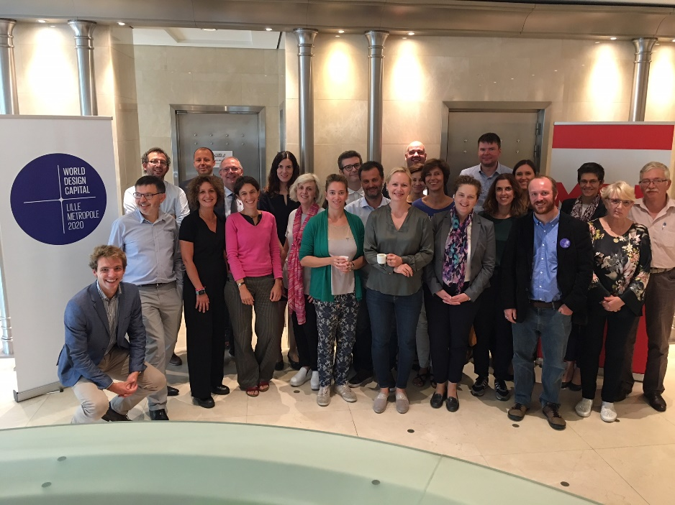

Proposal for a general integrated action plan at network level

APN overall priorities
Based on the policy challenge described above and according to the state of the art and what cities already know about the issue, partners will work together to answer three main problems:
- How can local administrations embrace innovation within its public services through the use of design?
- For which policy fields requiring innovative action do design methods bring added-value?
- How the use of design transform the city governance?

The following list of priorities and solutions details what hide behind these three questions.

List of priorities to be tackled by the APN
The challenges put when using design methods at administrative level is translated in diverse ways at local level; all of which represent issues the APN wants to reflect upon:
- What are the right ways to integrate design function in the city organisation?
- How to perform a cultural change to convince the “design sceptics” in the administrations and in the society?
- How to provide training courses of design methods for public employees?
- How to benefit the most from public innovation labs?
- How to better assess (quantitatively) the effects of local policy when elaborated through design
- How to assess the impact of design within the organisation?
- Testing new design models and prototyping;
- How to use design to make different departments and different administrations better coordinated?
- How to decentralize resource allocation from planning to iterative implementation (implementing/testing/prototyping)?
After the analysis of the problems when using design methods, options for solutions are manifold. Cities uses different paths to integrate design skills in their governance which can all be shared, exchange, up-scale, and adapted to local context through benchmarking good practices, testing new design methodologies in “proofs of concept” (POC) projects, sharing views and results on this public policy making driven by integrated design expertise within the local governance at large (internal or external to the administration).
In a nutshell, the APN will be the opportunity to compare, challenge, and assess the different approaches of collaborative innovation within public services.
Knowledge, feedbacks of following activities can be shared between partners to answer the above-mentioned questions:
- develop shared values around design within the local authorities,
- demonstrate the full value chain of design integration in public administration,
- mainstreaming design methods,
- running a successful policy lab,
- integrating a designer within the administration,
- impact measurement of design,
- ways of working in fragmented governance structures citywide,
- ways to adapt our local administrations to embrace design (e.g. transversal department, external expertise, chief design officer, staff trainings etc.).

List of key achievements
- Study visits

A comparison on the different methods of innovative co-creation through city/site visits which can include, as per examples:

- Thessaloniki : Hellenic Design Center as policy lab
- Dublin : Design to deal with fragmented governance structures
- Lille Metropole : Transfo as a transversal program to transform the administration and WDC2020
- Helsinki : the pros and cons of the Chief Design Officer function
- Baia Mare : Structuring the administration as to respond to users’ demands and identifying unmet stakeholders’ need
- Ghent : Testing and prototyping solutions and impact measurement
- Turin : Open Incet innovation center and training school focused on design for public employees
- Bologne : “Administrative simplification and promotion of active citizenship” office, “innovative lab”, and “civic imagination office”
Besides benchmarking on administrative practices, each city can also organize a site visit presenting the implementation of design on a specific public policy (spatial planning, housing, social innovation etc.). Integrated Action Plans will be fuelled by these study visits.
- A guide for policy makers in three parties:
- Guidelines for initiation steps in using design methods in elaboration of public policies:
  - Identifying where to direct design investment
  - Communicating on design methods to reassure design-sceptic in administration and citizens
- Guidelines for running a user-centred administration
  - Investing in and run an innovative policy lab
  - Integrate design within public administration culture
  - Identifying final users
- Guidelines post-design uses: whether to go further with design or not.
  - How to evaluate impact of design
  - How to communicate on design
  - How to reach other excluded users groups

Who’s involved in producing it? Each city visit will be focus on one of the guideline’s chapter. The best practices of the city visited will constitute a chapter. Lille Metropole would lead on document formatting. This guide will be a great base for the final objective of the APN (i.e. make policy makers sign an action plan).
- Pilots implementation projects
Following the process of benchmarking and guideline drafting, will implement what have been learned on a chosen policy challenge specific to its territory. These local pilot projects run with ULGs will:
- allow amendment to the guide for policy makers
- showcase the wide possibilities for implementation of design methods.
- testing and settling down the transformation of the public administration

- Impact assessment tool
Similarly to what the €Design project did on measuring the impact of design in boosting GDP, the last deliverable of the project would aim at developing a tool to measure the impact of design in the success of a policy.

URBACT Local Group and partners’ role
Cities willing to get involved in Action Planning Networks shall also commit to work on their policy challenges using a participatory approach that is involving all relevant stakeholders (from within the local administration and also outside, civil society, private sector, associations, etc.) in the action planning process. These key stakeholders will be gathered in an URBACT Local Group. They will be actively involved in the transnational exchange activities and in the development of the Integrated Action Plan to be produced by the city.
We foresee an innovative way to construct the ULG: to fit with the objective, ULGs could be composed of two groups: on the one side of the table local universities, design agencies, citizens involvement associations etc. could work on the integration of design in the public administration, on how to assess design a posteriori, to run design policy labs the best way etc. On the other side of the table will sit the local stakeholders relevant to the subject of implementation chosen by the city of the piloting. This local stakeholders (associations, local actors etc.) will accompanied the city in the implementation to ensure a successful delivery of the action plan. With this type of composition, the ULG could be seen as building the ecosystem of the design innovation lab considering both the implementation’s needs and the administrative needs. It is the role of the partners to build up their ULG, animate it and co-create the integrated action plan and the pilot phase with it.

Prospected Time line
Project creation:
- Novembre 2018 : Partners formal commitments and/or feedback
- December 2018 : Lille Metropole to propose a consortium for phase 1
- January 2019 : URBACT Call for Proposals and Info Day in Paris
- February 2019 : bid-writing co-writing
- March 2019 : Deadline for phase 1 application
- June 2019 : Project approval
Phase 1: end of 2019
- Study visits
- Guidelines book writing to elaborate a common vision and methodology for IAP
- Definition of a coherent consortium for phase 2
- Definition of a selection of policy areas where design methods will be tested
- Bid-writing for phase 2

Phase 2: mid-2020 to mid-2022
- Study visits
- Elaboration of a first draft of the guide based on study visits and benchmarking
- First pilot phase when each cities test their design methods on a policy area
- Report from first pilot and fine-tuning of the guidelines
- Second pilot phase and Impact assessment of it
- Dissemination and conclusion

