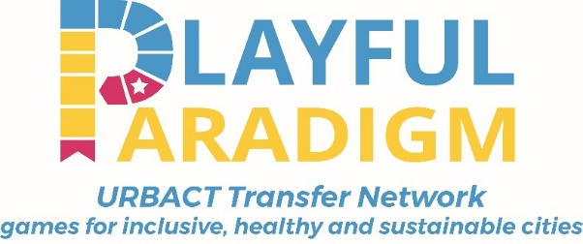
Municipality of Udine (Italy)
Short description of Transfer Network
Cities offer unique opportunities to face the challenges of urbanization, aging, climate change, social exclusion, only if favourable and pleasant places are co-created.
The Playful Paradigm project aims to transfer the Good Practice developed by the Municipality of Udine in more than twenty years based on a Play Strategy as a innovative concept to promote social inclusion, healthy lifestyles and energy awareness, intergenerational and cultural mediation, the creation of places and economic prosperity.
Play offers new strategies to attract the city's stakeholders in urban development, triggering the citizens participation, promoting a playful education, boosting sustainability and health and re-designing urban spaces.

The Playful Paradigm Transfer Network helps cities to adapt and reuse the Play Philosophy by transferring practical play activities and training the municipal staff and local stakeholders dealing with play approach.
In particular we will focus on:
- the set up and implementation of a Toy Library and a Ludobus (the mobile toy Library);
- the design of a playful education approach for involving schools and non-formal educational centres;
- the promotion of play place making to re-think city public spaces;
- innovative play projects to engage with vulnerable groups such as elderly people, youth, women, migrants and children.

In this second project wave we are also keen in promoting as a Network the idea to launch the European Capital of Play and in co-creating new digital games for supporting the urban planning activity and creating new tools for boosting a blended participation formula aimed at tackling the digital divide and offering new opportunities of inclusion through the digital environment.
Further information at URBACT website https://urbact.eu/playful-paradigm-0

 | Institution details
 | 1 |  | Name of the Partner
 | 2 |  | Member State
 | 3 |  | Contact details of the local coordinator
 | 4 |  | VAT number
 | 5 |  | VAT recoverable | YES NO partially
 | 6 |  | Short description of the City
 | 7 |  | Is your city part of a Less Developed Region? | YES NO
 | 8 |  | Is it a transition Region? | YES NO
 | 9 |  | Which European and world networks are you member of (i.e.: Energy Cities, Covenant of Mayors, Healthy Cities)?
 | 10 |  | Are you currently partner in an URBACT network or applying to join others? If yes which one(s)?
 | 11 |  | Who from your city would take part in transitional exchange meetings? (Ability to speak English is needed)

Information on Transfer Cities
1 |  | Name of the city
2 |  | Population
3 |  | What is the motivation of the receiving partners in joining the project?
4 |  | What are the needs and challenges which do you think can be addressed by this new practice and why do you think this practice could be the answer?
5 |  | What are the policies and concrete actions developed by the partner city in relation to the theme of the good practice?
6 |  | Which are the experiences and actions that you have already implemented to tackle the challenges of the project or other experiences related to urban games as promoters of social inclusion?
7 |  | What resources can you mobilise for transferring the practice? (staff and financial)
8 |  | Which stakeholders does the partner city plan to involve in a URBACT Local Group to ensure participatory approach and the successful transfer of the Good Practice (detail relevance of competences and resources)?
9 |  | How do you think the Good Practice Transfer will provide solutions for your local context?
10 |  | Which could represent barriers at local level to transfer the Good Practice? |  |  | -
11 |  | What is the experience of the partner city in terms of working through transnational exchange? Have you other experiences related to the topic?
12 |  | What is your potential contribution to the network activities and what do you expect from the network?

Thank you for your contribution!

